TEMPERATURE DEPENDENCE ON THE PASSIVE EFFECTS OF K+ ON MEMBRANE POTENTIAL OF SKELETAL MUSCLE : EDUCATIONAL MODULE

By
Pooja Naidugari^{1,2}, Dara Buendia Castillo^{1,2}, Esther E. Dupont-Versteegden^{2,3} and Robin L. Cooper^{1,2}
¹675 Rose St, Department of Biology, University of Kentucky, Lexington KY 40506-0225 USA
²Center for Muscle Biology, 900 South Limestone, University of Kentucky, Lexington KY 40536-0200 USA
³Charles T. Wethington Jr. Building, 900 South Limestone, University of Kentucky, Lexington KY 40536-0200 USA

PURPOSE
To understand the properties of excitable membranes in relation to the ionic basis of the resting membrane potential and the relationship to temperature. This is also designed as a teaching tool for advanced physiology and neurophysiology student laboratories.
ABSTRACT
In modifying a typical physiological laboratory protocol in measures of the resting membrane potential in relation to the concentration of extracellular potassium ions [K⁺]_{o,} the additional effects of temperature were addressed. The effects of temperature on the membrane potential are not commonly addressed in experimental physiology and neurophysiology student laboratory exercises. In terms of presenting an authentic application of the experimental design, various topics were highlighted. Heterothermic animals were used as models in addressing the effects of environmental change as one topic, and a second focus was on clinical therapies related to the use of varied temperatures in mammals. A third topic focused on a unified issue with all organisms in temperature changes with cellular metabolism. Experimentally, the skeletal muscle of a crayfish served as a model to obtain data. The crayfish model is robust for long term survival in minimal physiological saline, is easily obtainable, and , and allows for a relative ease in dissection. Graphing membrane potential in relation to both [K⁺]_{o} and temperature, along with theoretical curves for the Nernst and Goldman-Hodgkin-Katz (G-H-K) equations, provides important distinctions and understanding of the relationship of temperature in these equations. Freely available online software is used in addressing the theoretical values one would expect. Discussion of other factors impacted by temperature for biological membranes will also be covered.
Introduction
The common student physiology laboratory protocol for teaching content on the resting membrane potential is generally to vary the extracellular potassium ions [K⁺]_{o} in relation to the membrane potential. If experimentally determining this relationship, participants would vary the [K⁺]_{o} while taking measures of the membrane potential with intracellular recordings. The experimentally obtained values are usually plotted in relation to the theoretical Nernst equation. The deviation in the curves would likely bring up the topic of the Goldman-Hodgkin-Katz (G-H-K) equation and why the G-H-K equation is a better fit for the experimentally obtained data (Atwood and Parnas, 1968; Baierlein et al., 2011; Johnson et al., 2014; Wyttenbach et al., 1999).
Thus, these common laboratory exercises become very standard and referred to as "cookie cutter" exercises. The exercise presented in this paper is designed to provide alternative tweaks to a standard protocol for novel investigative purposes. Hopefully this will engage more participation in learning the related content as well as enjoyment in conducting a laboratory exercise. We refer to this type of class exercise as an Authentic Undergraduate Research Experience (ACUREs) as these allow novel projects to be developed with a goal in publishing the findings and offering students an advanced scientific undertaking by publishing their results. In the past, this general lab in the resting membrane potential with varied extracellular concentration of potassium ions (i.e. [K⁺]_{o}) was taught in the concept of muscle or neuronal injury and spillage of K+ adding to [K⁺]_{o}. (Cooper et al., 2019). However, an additional twist is using homogenized muscle (i.e., muscle juice) at various dilutions and examining the membrane potential (Thenappan et al., 2019). An additional perturbation which students had an interesting experience conducting was to add the effects of muscle juice on evoked synaptic transmission and the occurrences of spontaneous quantal events as well as shapes in the evoked and single quantal events (Thenappan et al., 2019). The preparation used offers unique experimental outcomes and potential follow up experimentation. For example, since crayfish and many insects use glutamate as the neurotransmitter at the neuromuscular junction, the glutamate receptors become desensitized during the muscle juice application which is likely due to the amount of glutamate within the homogenized muscle. Thus, the evoked and spontaneous quantal events become smaller than are observed for the same amount of muscle depolarization due to reducing driving gradient of the Na⁺ influx through the inotropic glutamate receptor with the raised [K⁺]_{o}. This resulted in students designing new experiments with raised [K⁺]_{o}. and adding in small amounts of glutamate to mimic the responses observed with the muscle homogenates. In addition, the concepts of raised [K⁺]_{o} within one class were expanded to the whole organism, then to the effects on other cells (i.e. peripheral sensory neurons) besides the ones in proximity to the muscle fibers as an ACURE project to the point of publishing novel results (Malloy et al., 2017).
This exercise is focused on a novel approach of combining the standard membrane potential and raised [K⁺]_{o} paradigms to include the effect of temperature on the membrane potential. By relating this integrative topic to real world applications, three general themes are presented for students to contemplate. The first theme is to address the topic with heterothermic animals, such as crustaceans and insects, which can be exposed to wide variations in temperature abruptly as compared to seasonal changes or longer term climate change. In addition, addressing a true hibernating mammal, such as a squirrel, and the effects on cells within this animal. The second theme is to address the potential implications with clinical therapies, such as a cold or warm pack on injured tissue and a cold induced coma for reducing neural function. In addition, a third theme in the commonalty regarding heterotherms and homeotherms with cellular metabolism which results in thermal changes.

{all future tense}
Theoretical calculations empirical measures of membrane potential

To begin this exercise the Nernst equation and Goldman-Hodgkins-Katz equation (GHK) need to be addressed.
Equations that are commonly used to determine the equilibrium potential of an ion and resting membrane potential are the Nernst equation and the Goldman-Hodgkin-Katz (G-H-K) equation, respectively. An important distinction between the two equations is that the Nernst equation is used only for one specific ion to determine the equilibrium potential for that ion, whereas the G-H-K equation is used to determine the resting potential by considering the permeability of multiple ions and their gradients across a cell membrane (Nernst, 1888, 1889; Goldman, 1943; Hodgkin and Huxley, 1952; Hodgkin et al., 1952; Hodgkin and Katz,1949; see Hille, 1992).

The Nernst equation is generally considered for ions across a membrane generating an electromotive force as commonly shown as:
$$V=\frac{RT}{zF} ∙ln\frac{⁡{[X]}_{out}}{{[X]}_{in}}$$

X = ion of interest
V = equilibrium voltage for the X ion across the membrane
R = gas constant [8.314 J/(mol•K)]
T = absolute temperature [Kelvin]
Z = valence of the ion
F = Faraday's constant [9.649 × 104 C/mol]

For the K⁺ ion at 20ºC and transformation of ln to log₁₀ along with filling in the constants, one arrives at:
$$Potential=58 log\frac{{[K]}_{out}}{{[K]}_{in}}$$

Let us assume that only K⁺ is permeant by diffusion. [K_{in}] is the K⁺ concentration on the inside of the cell and [K_{out}] is the K+ concentration on the outside of the cell.

As an exercise estimate [K_{in}]. ______________

Assume for this calculation, membrane potential is only dependent on the K⁺ equilibrium potential.

Given the [K_{out}]= for the saline used is 5.4 mM. Also, assume membrane potential is -70mV.

$$Potential=58\log{\frac{5.4}{{[K]}_{in}}}$$
-70/58=log 5.4/[K in]
-1.2069= log 5.4/[K in]
Antilog -1.2069= 5.4/[K in]
10^{-1.2069}= 5.4/[K in]
0.0621= 5.4/[K in]
[K in] =5.4/0.0621=86.95 mM
Double check
X= 58 Log (5.4/86.95)= -69.999 so close enough to -70 mV
Considering that a membrane can be permeable to more than one ion at rest, as well as at various depolarized states, one uses the G-H-K equation to take into account the permeability (P in the equation) for various ions. The G-H-K equation will reduce to the Nernst equation if a membrane is permeable to only one ion.

Here is a generalized G-H-K equation for Na⁺, K⁺, and Cl⁻ ions:

$${Em}_{K, Na, Cl}=\frac{RT}{F}\ln{\frac{P_{{Na}^{+}}{\left[{Na}^{+}\right]}_{out}+P_{K^{+}}{\left[K^{+}\right]}_{out}+PCl[Cl]in}{P_{{Na}^{+}}{\left[{Na}^{+}\right]}_{in}+P_{K^{+}}{\left[K^{+}\right]}_{in}+PCl[Cl]out}}$$

Since Cl⁻ has a negative charge, the concentration term is inverted in this equation for the inside and outside. This allows the Z (ion charge) to be left off.

A free software database allows one to put in different values for temperature and other variables in the GHK equation for a quick response in the expected membrane potential. The use of the rapid computer simulation helps to demonstrate the effect of the various parameters on the membrane potential as well as how slight changes in one parameter can have a large role in the outcome.
The main emphasis for this exercise is on how different temperature values and [K⁺]_{o} affects the membrane potential.
Given the values reported in the literature for crayfish muscle we use these as a reference. The concentration of K+ in the saline we start off with is 5.3 mM and the temperature is 21 C (Note: We will take the temperature of the saline in which we conduct these experiments in practice).
There are values estimated for neurons (Atwood 1982) which we could use as well for comparison in muscle fibers.
[Na]_{i} = 17.4 mM (for neurons, Atwood 1982)
[K]_{i} = 265 mM (for neurons, Atwood 1982)
[Cl]_{i} = 12.7 (for neurons, Atwood 1982)
pK = 1 (for neurons, Atwood 1982)
pCl = 0.1 (for neurons, Atwood 1982)
pNa = 0.001 (for neurons, Atwood 1982)

For crayfish muscle:
“Procambarus and Astacus [K]_{i} appears to be 171 and 167 mM, respectively.” (Katz et al., 1972). We are using the values for Procambarus.
[K]_{i} = 171 mM (determined for crayfish muscle)
[K]_{o} = 5.3 mM (Saline)
[Na]_{i} = 17.4 mM (assume for muscle)
[Na]_{o} = 205 mM (Saline)
[Cl]_{i} = 12.7 mM (assume for muscle)
[Cl]_{o} = 232.15 mM (assume from saline; 205 mM NaCl; 5.3 mM KCl; 13.5 mM
CaCl₂2H₂O; 2.45 mM MgCl₂ 6H₂O)

pK = 1 (assume for muscle)
pNa = 0.001 (assume for muscle)
pCl = 0.01 (assume for muscle)

Use the on-line simulator from
Online https://www.physiologyweb.com/calculators/ghk_equation_calculator.html
(note: values of temperature are in K which is 273.15 + the # in centigrade)
Graph the results obtained from the online simulation for membrane potential based on the above values and for 5.3 mM, 10 mM, 20 mM, 30 mM, 40 mM, and 50 mM for [K]_{o} and using 5ºC, 10ºC, 21ºC, and 30ºC . Plot in a similar manner to those obtained for the barnacle muscle (Figure 1; copied from Fischbarg, 1972; https://doi.org/10.1113/jphysiol.1972.sp009886).
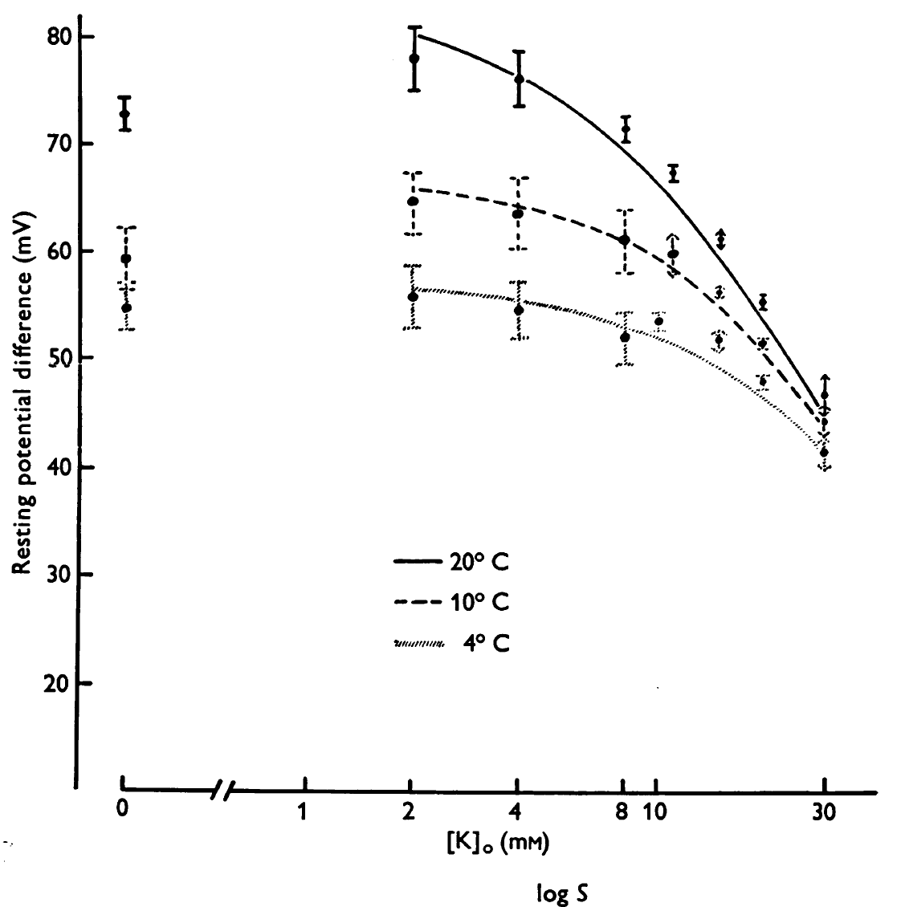
Figure 1: copied from Fischbarg (1972). https://doi.org/10.1113/jphysiol.1972.sp009886
To obtain the experimental data, we will measure in muscle fibers from a freshly dissected crayfish with sharp intracellular electrodes while changing the surrounding environment. Crayfish are used as the experimental organism as they survive for long periods of time with minimal saline composition.
The [K⁺]_{o} and temperature values are varied and the data is to be plotted and compared against the curves that was obtained from the computer simulations above.

METHODS

Materials

- Scissors (1)
- Forceps (1)
- Silver Wire for ground wire (1)
- Microscope (1)
- Electrode Probe (1)
- Petri Dish with Sylgard on the bottom (1)
- Saline Solution (1)
- Potassium Solutions: 5.4mM (normal saline), 10, 20, 40, 80, 100 mM
- Bleach (Small Amount, Use for the tip of the silver wire to build Ag-Cl)
- Glass Pipette (1), to remove and add solutions
- Syringe (1)
- Amplifier/Acquisition System (1)
- Faraday Cage (1)
- Desktop/Laptop (1)
- Dissection pins (4)
- Crayfish

Preparation/Dissection:

1. A crayfish approximately 6-10 cm in body length should be obtained (or a manageable size). Hold the crayfish at the back of the head or approximately a centimeter from the back of the eyes. Ensure that the claws of the crayfish or its mouth cannot reach the individual handling the crayfish. (The crayfish may be placed in crushed ice for 5 minutes to anesthetize it prior to cutting off the head.)

2. Use the large scissors to quickly remove the head. Make a clean and quick cut from behind the eyes of the crayfish. Dispose of the head and appendages.

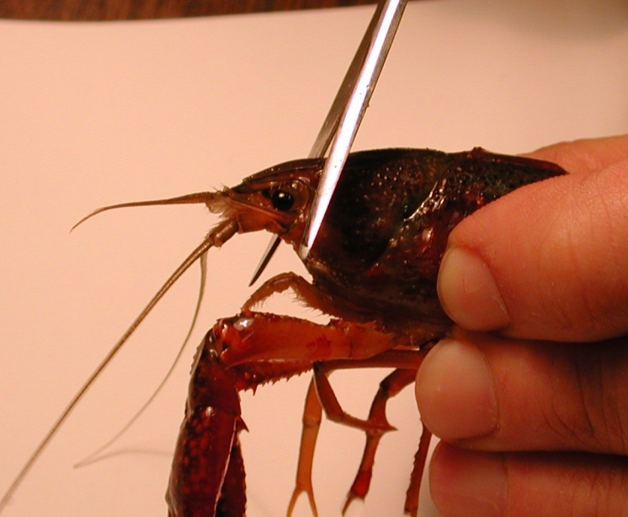
Figure 2: Image shows placement of the cut to remove the head of the crayfish.

3. The legs and claws of the crayfish can be removed at this point to avoid injury. Stylets on males and swimmerets on both males and females can also be removed (Figure 3). Next, separate the abdomen from the thorax. Make a cut along the articulating membrane, which joins the abdomen and thorax (Figure 4). Save the abdomen portion of the crayfish and dispose of the thorax.

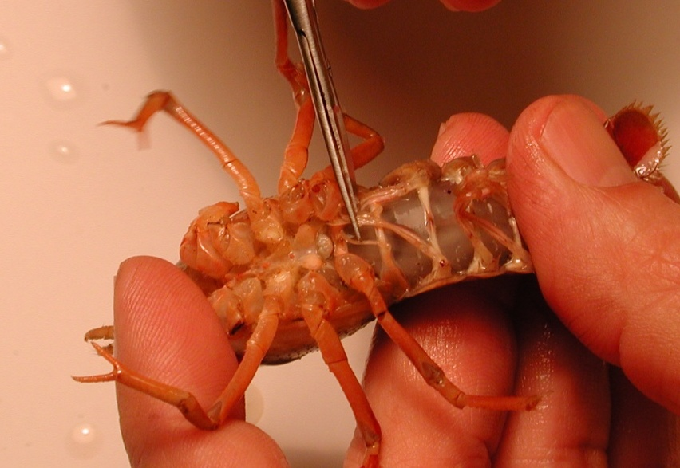
Figure 3: The scissors are cutting the stylets. These can be removed from the crayfish.
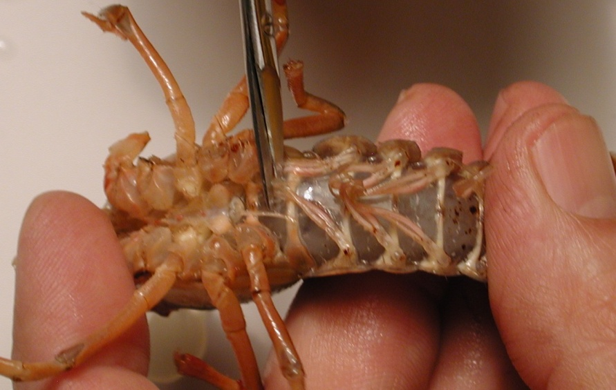
Figure 4: Image shows the placement of the cut to remove the thorax from the abdomen.
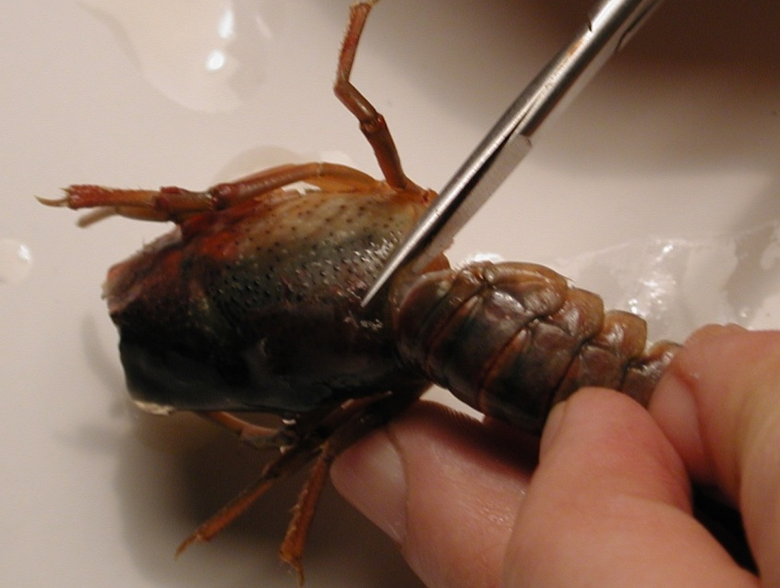
Figure 5: Removal of the thorax from the abdomen. The cut should be made in circular fashion along the line in the joining of the segments.
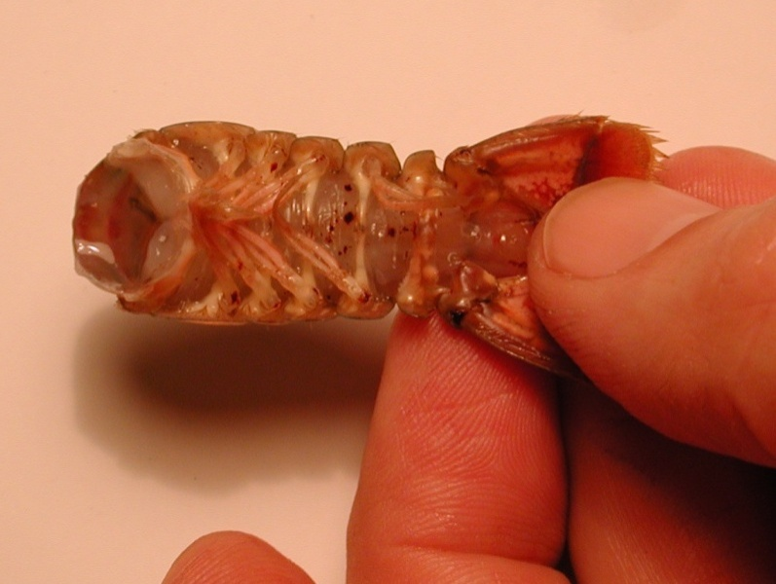

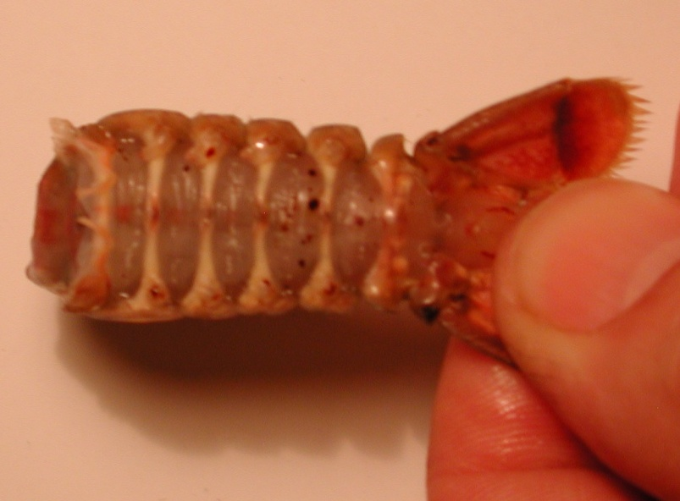
Figure 6: The top image shows the abdomen with swimmeret appendages. Bottom image shows the abdomen without the swimmeret appendages.

4. With the abdomen, a cut should be made in the shell along the lower, lateral border of each side of the abdomen. Care should be taken not to cut too deeply into the crayfish. To help in the process of cutting the shell, the cut should be made with the scissors pointing slighting down towards the ventral side and at an angle. Follow the natural shell pattern of lines of the crayfish that run the length of each segment (Figure
7).
Figure 7: Scissors are placed at an angle and follow the natural alignment of the shell. Do not cut too deep and destroy the preparation. The arrowheads point to the natural line along each segment that should be followed for the cuts.

5. Remove the ventral portion of the shell. Take care not to destroy the abdominal muscles. Use forceps to remove the ventral portion. When the ventral portion of the shell is removed, a white mass of tissue can be seen on top of the deep flexor muscles. This tissue can be removed carefully with forceps.
Figure 8: Removing the ventral portion of the shell with forceps. Pull up and back on the ventral portion to remove. Do not destroy muscles under the ventral shell.

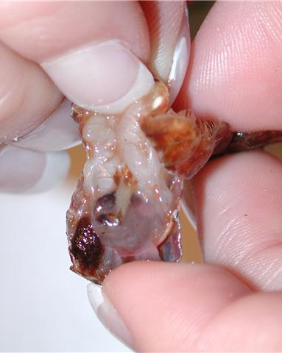
Figure 9: Pulling back on the ventral portion of the shell, which is to be discarded.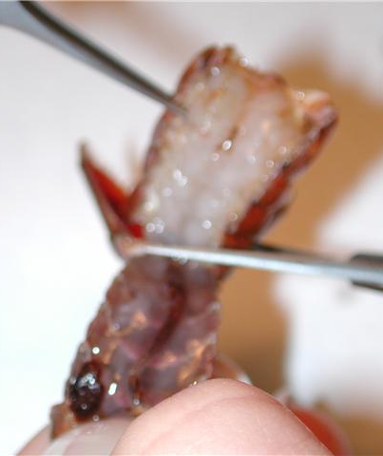
Figure 10: Cut the ventral portion of the preparation with scissors and discard.

6. The GI tract, a small tube running along the midline of the deep flexor muscles, can be removed from the crayfish. Pinch the top of the tract with the forceps and pull away from the abdomen. Cut the bottom of the tract – at the end of the tail. Rinse the dissection with saline to ensure the fecal waste does not interfere with the preparation.
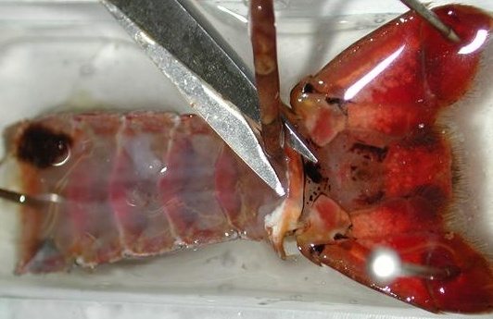
Figure 11: Image shows the removal of the GI tract from the preparation.

7. Use dissection pins to secure the preparation to the Petri dish. The top and bottom corners of the preparation should be pinned down to the dish. Saline solution should be poured into the Petri dish and cover the preparation completely until intracellular recordings are performed.

This dissection dish should have a Sylgard (Dow Corning) coating on the bottom (1cm thick) so that insect pins can be stuck into it.

Dissected preparations are bathed in standard crayfish saline, modified from Van Harreveld’s solution (1936), which is made with 205 NaCl; 5.3KCl; 13.5 CaCl₂; 2H₂O; 2.45 MgCl₂; 6H₂O; 5 HEPES and adjusted to pH 7.4 (in mM).

Intracellular Recording
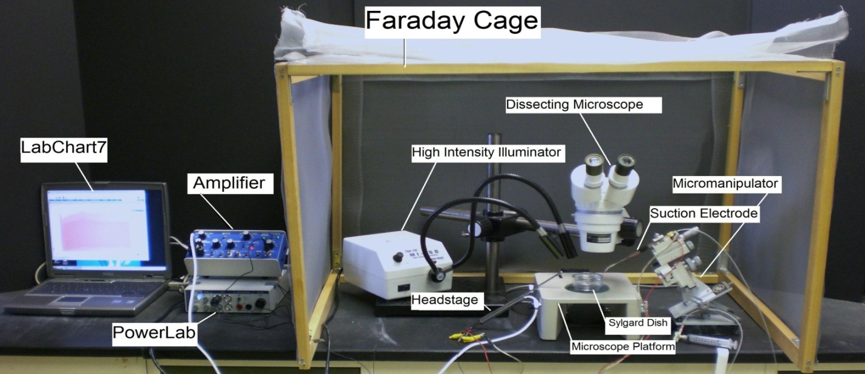
Figure 12: General setup of the recording equipment from. Specific set-ups may vary with different electrodes.

8. The specimen dish with preparation should be placed under the microscope and secured with poster tack beneath the dish to prevent movement.

Figure 13: Placement of the preparation under the microscope. Use poster tack (shown in blue) to secure the specimen dish and ground wire to the stage of the dissecting scope.

9. Two wires each with a short length of silver wire attached to one end should be obtained. The silver wire should be dipped into a small amount of bleach for about 20 minutes to obtain an Ag-Cl coating. Wash the wire with distilled water before using. A glass intracellular pipette should be obtained and carefully backfilled with a long needle attached to a syringe filled with a 3M KCl solution. The pipette should be turned down (with the opening facing the floor) and filled with solution. This will ensure that any excess KCl will drip out the back of the electrode. Be sure no KCl runs along the glass pipette that will enter the saline bath. Turn the pipette upright when finished filling with potassium chloride solution. The silver wire can then be placed into the pipette. The other end is connected to the +(positive) pole on the amplifier head stage. The pipette is then secured on the electrode probe. Care should be made not to break the electrode tipLastly the Ag wire of the remaining lead should be placed in the bath and the other end attached to the – (negative) pole shown below. A wire should also be placed from the Faraday cage to the ground portion of the AD converter Powerlab. The head stage is connected to the “input-probe” on acquisition/amplifier (Powerlab).

Figure 14: Microelectrode assembly with glass capillary in place.

The intracellular amplifier used during the intracellular membrane potential recordings has a button to use to test electrode resistance and can be read directly off the digital screen. The amplifier can be set-up to record 1 X or 10 X output on a computer based on which BNC output is used.

Software Set-up
10. Be sure your amplifier and PowerLab units are on before opening the software!
11. Open the LabChart software. Adjust the chart to display only one channel by clicking “Setup”, then “Channel settings.” Under “Channel settings,” change number of channels to one. Click “OK.”
12. At the top of the chart, left hand corner, cycles per second should be 2K. Set volts (y-axis) to around 1V.
13. Click on “Channel 1” on the right hand portion of the screen. Click “Input Amplifier” and that the following settings are selected:

Single ended | OFF
Differential | Checked
AC-Coupled | OFF
Anti-alias | Checked
Invert | OFF

14. CHECK THE RESISTANCE OF YOUR ELECTRODE.

To measure the resistance, place the tip of the glass electrode into the saline bath. Make sure a ground wire is also in the saline bath. While recording, the Ω TEST switch should be turned on and then off several times. The amplitude (mV) of the resulting changes should be measured. To measure the amplitude changes in the trace, place the marker on the steady base line and then move the cursor to the peak amplitude off computer traces or read the values directly off the digital output on the amplifiers.

Average Resistance (MΩ) = ____________________

The resistance should be within 20 to 60 MegaOhms. Low (<20) and high resistance (>100) are not acceptable. Troubleshoot as necessary to bring your electrode’s resistance within the acceptable range.

15. NEXT, SET YOUR EXTRACELLULAR VOLTAGE TO ZERO. Set the gain in your software to 1 or 5 V/div. Begin recording by pressing “start” at the bottom of the screen. Use the DC offset knob on the amplifier to adjust the recording trace to zero before inserting the electrode into the tissue. This sets your extracellular voltage to zero.

16. Use the micromanipulator and dissecting scope to insert the microelectrode tip into the longitudinal muscles (DEM or DEL1 or DEL2) of the preparation (see Figure 15 and 16). The electrode should barely be inserted into the muscle. You will likely see the muscle dimple as the electrode penetrates. Do not penetrate completely through the muscle. The high intensity illuminator should be adjusted to clearly see the muscle as the electrode is being inserted. When poking muscle fibers in this preparation one can commonly run into spaces and clefts within the muscle. This is the reason why the membrane potential can appear, then disappear, and then reappear.

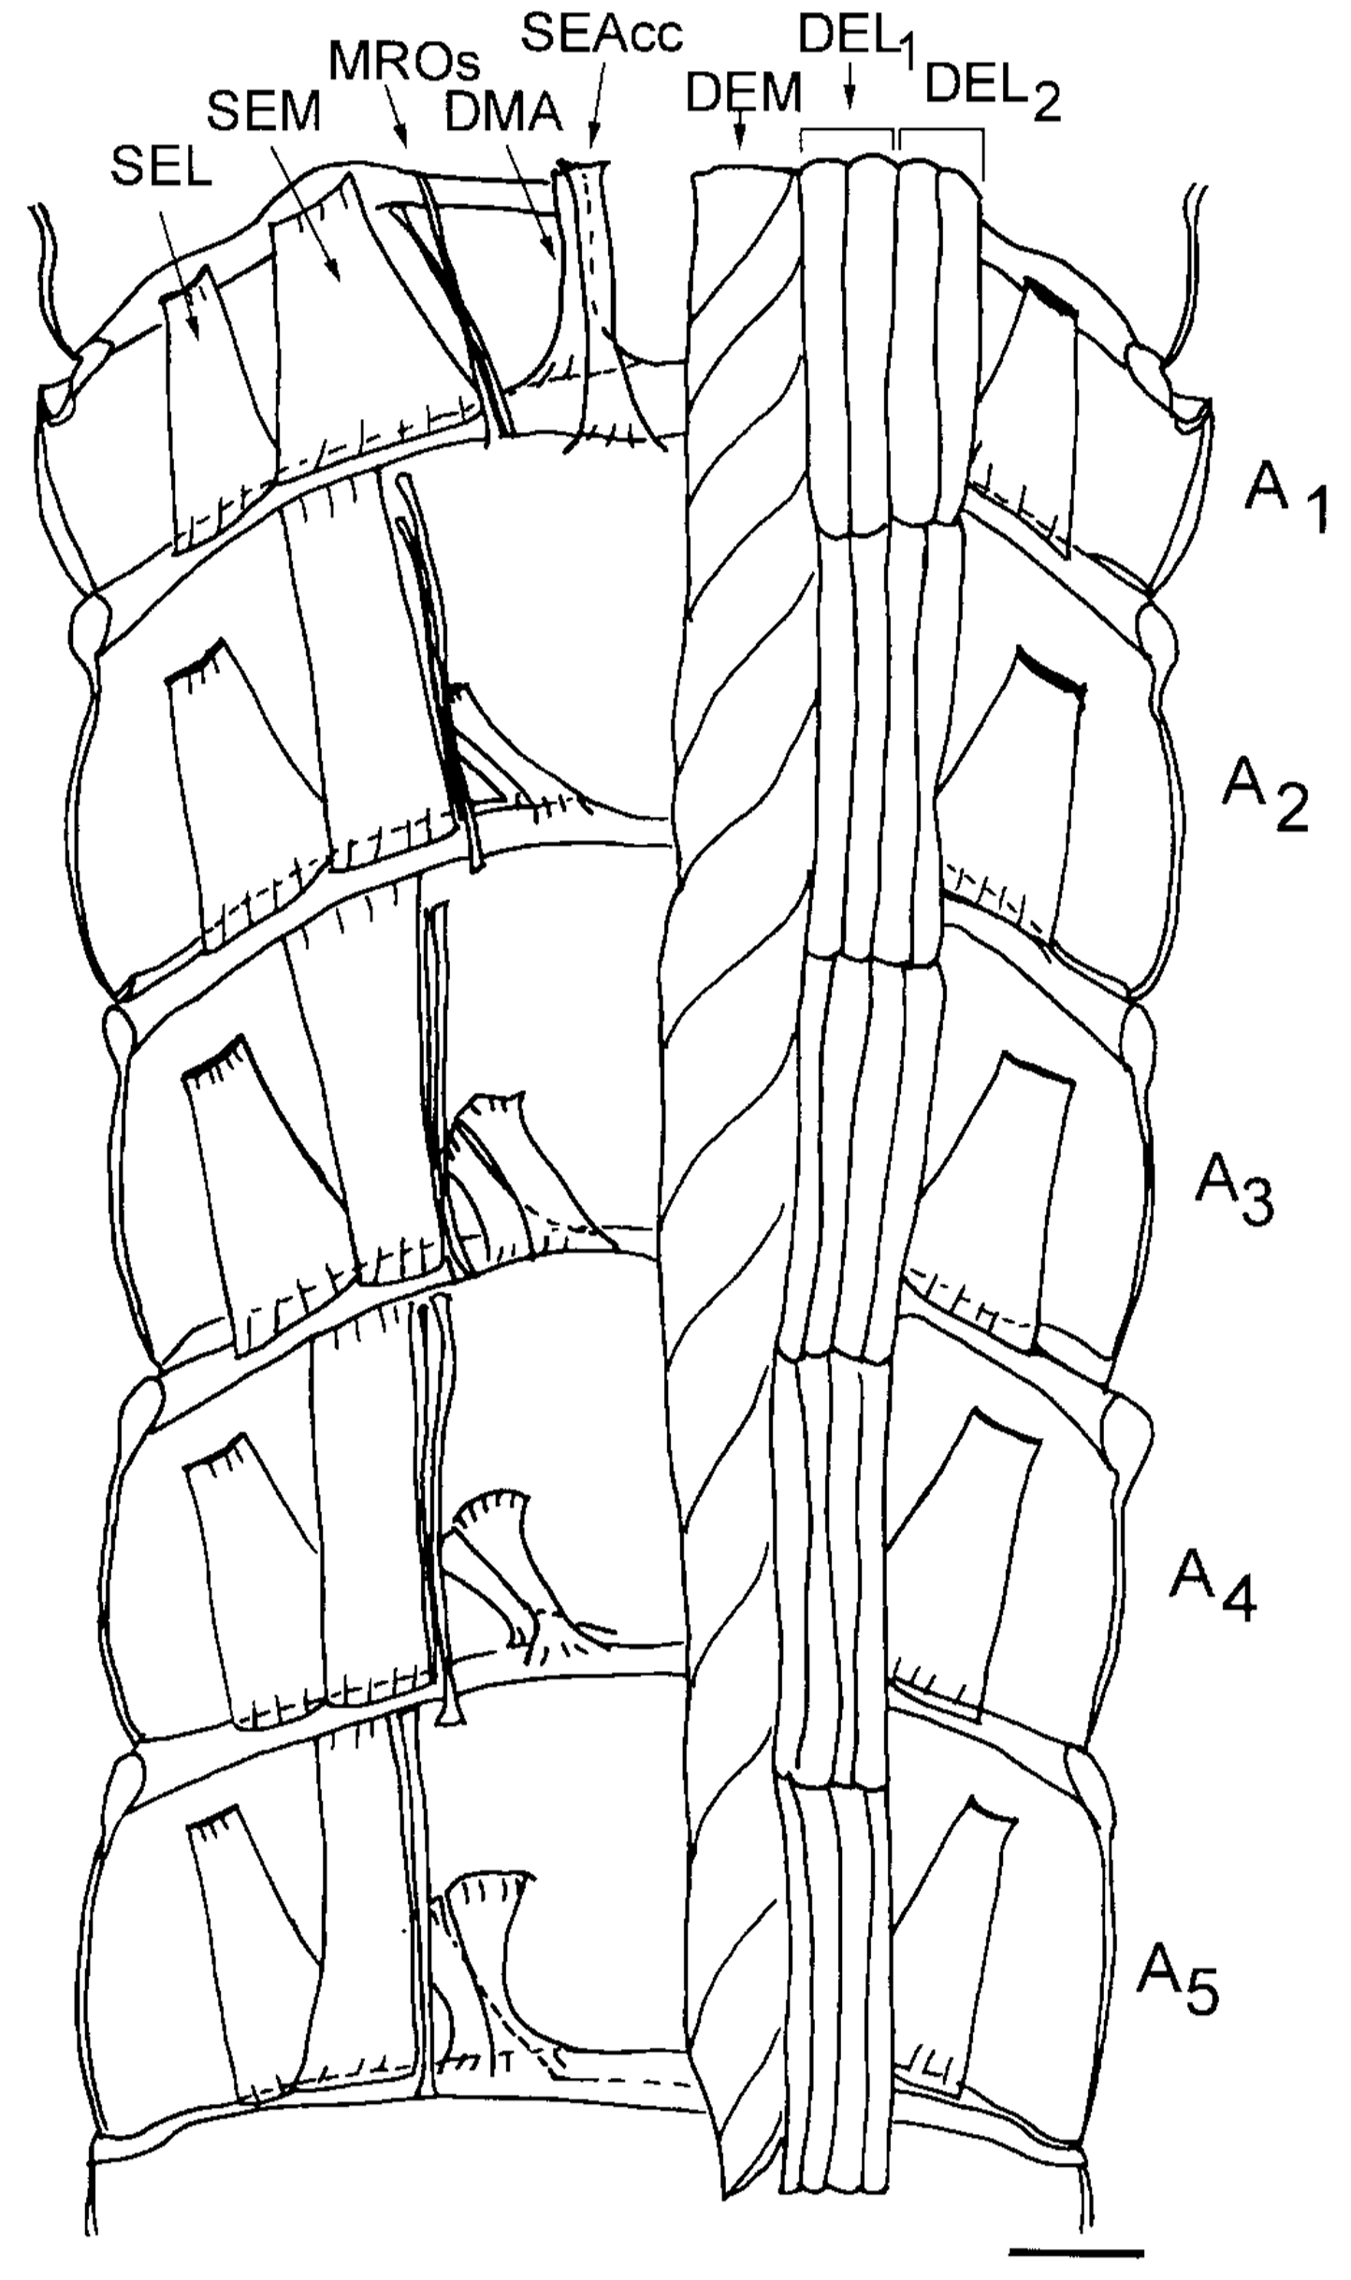
Figure 15. Schematic drawing from a ventral view of the dorsal part of the crayfish abdomen showing the extensor musculature of each segment. The dorsal membrane abdomen muscle (DMA) and the superficial extensor accessory muscle head (SEAcc) occur in segments 1 through 5 of the abdomen with a different orientation for each segment. With the exception of segment 1, these muscles have their attachment sites at their anterior end to the calcified tergite and at the posterior end in the articular membrane. In segment 1, the homologous muscles have their anterior attachment sites to the articular membrane located between the thorax and abdomen. The illustration was based upon photographic montages of methylene blue stained preparations. On the left side of the figure all the deep extensor muscles have been removed to show the dorsal superficial extensor muscles. Scale = 2.35 mm. (Taken from Sohn et al. 2000).

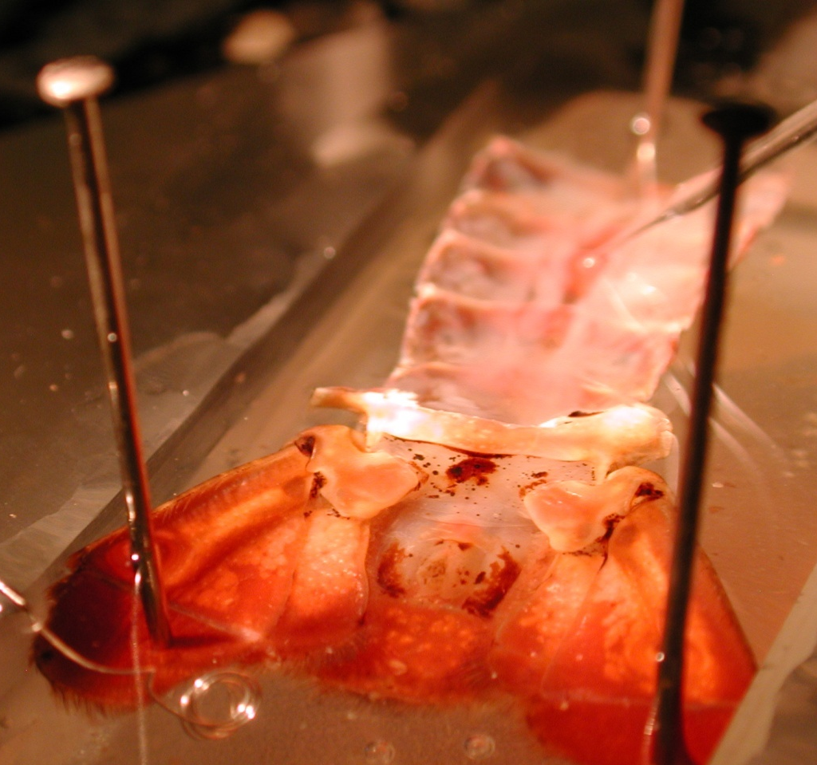
Electrode tip
Figure 16: Insertion of electrode into the muscle of a pinned preparation to the recording dish.

The difference in the computer recorded values might need to be adjusted to account for any amplification used on the amplifier (i.e. 10X amplification). The voltage should be converted to millivolts if the values are reported on the software as volts (1 V = 1,000mV).

17. Carefully use the dissecting scope and micromanipulator to withdraw the electrode from the muscle. Reposition the electrode, and insert the tip into another muscle fiber. Record the resting membrane potential. One should collect several recordings and be comfortable with measures as well as directing the intercellular electrode into the muscle fiber of interest before moving onto the next step.

18. The bathing solution can now be exchanged starting with 5.3 mM K⁺ to the series of 10 mM, 20 mM, 30 mM, 40 mM, 50 mM K+ concentrations and then returned to 5.3 mM.

19. After this series of [K⁺] was used then a second and third series was used but at 10ºC then 5ºC and finally at 30ºC. A period of 5 minutes was used for initial conditioning to the new temperature before proceeding with the next series of [K⁺] changes.

20. Fill in the table:
[K⁺]_{out} (mM) | Electrode resistance | Membrane potential (mV) | Bathing temperature
5.3 |  |  | 21
10 |  |  | 21
20 |  |  | 21
30 |  |  | 21
40 |  |  | 21
50 |  |  | 21
5.3 |  |  | 10
10 |  |  | 10
20 |  |  | 10
30 |  |  | 10
40 |  |  | 10
50 |  |  | 10
5.3 |  |  | 5
10 |  |  | 5
20 |  |  | 5
30 |  |  | 5
40 |  |  | 5
50 |  |  | 5
5.3 |  |  | 30
10 |  |  | 30
20 |  |  | 30
30 |  |  | 30
40 |  |  | 30
50 |  |  | 30

DISCUSSION AND THOUGHT PROBLEMS
As early as 1902, Bernstein was dealing with the issues of a resting potential in the axon of a squid. It is intriguing to consider how these early ideas and observations of Berstein (1902) and Nernst (1888) later influenced research in membrane physiology. (See review by Malmivuo and Plonsey, 1995; also available on the www http://www.bem.fi/book/ ). There are still, to this day, breakthroughs being made about ion channel function and properties of biological membranes that are very significant in understanding the cellular physiology which relates to the function of tissues, organs and systems.

The comparison of the experimental and theoretically derived effects of external [K⁺] on the resting membrane potential indicates the influence of ions on the membrane potential. Additional experiments using this same preparation remain to be performed to address fundamental physiological questions. Some were highlighted back in 1968 by Atwood and Parnas and have yet to be fully tackled. With the techniques obtained in this exercise, one can proceed to answer many questions remaining in other experimental preparations as well as in physiological applications related to medicine and health. We have demonstrated the usefulness of a model invertebrate preparation to address fundamental questions pertinent to all animals.

With the knowledge gained on the electrochemical gradients of ions in this above exercise, you can now advance to the excitability of membranes by examining synaptic transmission at neuromuscular preparations in the crayfish. One can also apply these concepts on other cell types such as neurons and cardiac tissue.

Concepts to address:

1. Ensure you can determine [K]_{i} given all the other parameters in the Nernst equation.

2. Discuss why the estimated Ek may not match the resting membrane potential measured.

3. Why are the slopes of the lines for the graphs of membrane potential and [K]_{o} not equal at different temperatures?

4. Why are the slopes not linear for the various [K]_{o} ?

5. Address why in the literature are ratios of Pk/PNa etc.. used instead of direct values in calculating membrane potential using the GHK equation?

One theme was to address the topic of heterothermic animals, such as crustaceans and insects that can be exposed to wide variations in temperature, and the effect of temperature change on excitable cells such as muscle and neurons. So would lowering the body's temperature alter threshold of a neuron or a heart cell? If so, would it be more or less excitable and why? Would the effect be just the opposite in excitability by the same amount if the temperature was raised (explain your reasoning)? Now consider a homeothermic animal such as a hibernating squirrel which can lower its body temperature with the environment. Would a similar effect occur to the cells of the squirrel with changing temperatures? How about the case for a human which functions best around a set temperature?
Therapeutic hypothermia is a type of treatment. It’s sometimes used for people who have a cardiac arrest. Cardiac arrest happens when the heart suddenly stops beating. Once the heart starts beating again, healthcare providers use cooling devices to lower your body temperature for a short time. It’s lowered to around 89°F to 93°F (32°C to 34°C). The treatment usually lasts about 24 hours.
Is this temperature change large enough to affect the resting membrane potential based on your experimental or theoretical/simulated calculations? Maybe plug in the change to the one line simulation provided and determine how much theoretically the membrane potential changed. What effect do you think it would have on membrane excitability?
Consider the following copied from an article (Showman and Wedlick, 1963):
" Conclusion
In summary, we conclude that the local application of cold combined with proprioceptive neuro-muscular facilitation rehabilitation techniques is the most effective measure we have found in the treatment of multiple sclerosis. We have also found that, when mobilization of a joint is required, if there is any muscle spasm, then it seems preferable to precede reeducation techniques by the local application of cold rather than heat. The local application of cold would seem to be the ideal emergency measure in the initial treatment of acute muscle and ligament strains. It is our experience that, to be effective, cold therapy must consist of moist cold applied to the skin itself. The two methods available are either a spray technique or the use of ice and water. If the spray technique is used, then a fluoromethane spray, such as "Sketron", seems on all grounds far preferable to spraying with ethyl chloride; it has the advantage of being applied easily to any site. However, when muscle spasm is severe, we believe that the use of packs soaked in a mixture of ice and water seems to produce more lasting benefit than the local use of a cooling spray."

What might be the logic in physiological concepts of why these cold treatments work for muscle spasms?

You might have seen on TV after major football games the athletes take ice baths. Do you think it is for the same reason to reduce muscle spasms? Are there any other physiological reasons?

Let us now switch over to metabolism of cells and heat production. When electrical activity of a neuron is induced, a rise of CO₂ from cellular metabolism and production of H⁺ occurs. The rapid diffusion of CO₂ across bilipid membranes can influence both intracellular and extracellular pH (Gutknecht et al., 1977). Cellular metabolism would also raise the local temperature, as you likely know well with just a small amount of exercise. So, is the increase in heat more of a positive-feedback or a negative feedback on cellular excitability of neurons and muscle cells? Lastly what might be the logic behind one's brain shutting off if one overheats as well as if it becomes too cold?

REFERENCES

Atwood HL. Membrane physiology of crustacean neurons. In Podesta RB, Ed. Membrane physiology of invertebrates; New York, Marcel Dekker, Inc. 1982; pp.341–407.

Atwood, H.L. and Parnas, I. (1968). Recording from the crayfish abdominal extensor muscle preparation with microelectrodes. In: Experiments in physiology and biochemistry (Kerkut GA, ed), pp 307-330. London: Academic.

Baierlein, B., Thurow, A. L., Atwood, H. L., & Cooper, R. L. (2011). Membrane potentials, synaptic responses, neuronal circuitry, neuromodulation and muscle histology using the crayfish: Student laboratory exercises, Journal of Visualized Experiments, 47, Retrieved from https://www.jove.com/Details.php?ID =, 2322

Bernstein J (1902): Untersuchungen zur Termodynamik der bioelektrischen Ströme. Pflüger Arch. ges. Physiol. 9: 521-62.

Cooper, R.L. Thenappan, A. and Dupont-Versteegden, E.E. (2019) Examining motor and sensory units as an educational model for understanding the impact of localized tissue injury on healthy cells. Article 6. In: McMahon K, editor. Tested studies for laboratory teaching. Volume 40. Proceedings of the 39th Conference of the Association for Biology Laboratory Education (ABLE). Vol. 40, Article 6, 2019
Fischbarg J. (1972). Ionic permeability changes as the basis of the thermal dependence of the resting potential in barnacle muscle fibres. The J. Physiol. 224(1):149–171.

Goldman DE (1943): Potential, impedance, and rectification in membranes. J. Gen. Physiol. 27: 37-60.

Gutknecht, J., Bisson, M. A., Tosteson, F. C. (1977). Diffusion of carbon dioxide through lipid bilayer membranes: effects of carbonic anhydrase, bicarbonate, and unstirred layers. J Gen Physiol, 69(6): 779-794.

Hille B (1992): Ionic Channels of Excitable Membranes, 2nd ed., Sinauer Assoc., Sunderland, Mass.

Hodgkin AL, Huxley AF (1952): A quantitative description of membrane current and its application to conduction and excitation in nerve. J. Physiol. (Lond.) 117: 500-44.

Hodgkin AL, Huxley AF, Katz B (1952): Measurement of current-voltage relations in the membrane of the giant axon of Loligo. J. Physiol. (Lond.) 116: 424-48.

Hodgkin AL, Katz B (1949): The effect of sodium ions on the electrical activity of the giant axon of the squid. J. Physiol. (Lond.) 108: 37-77.

Johnson BR, Wyttenbach RA, Hoy RR. 2014. Cruataceans as model systems for teaching neuroscience: past, present, and future. In: Nervous systems and control of behavior, the natural history of the Crustacea. (Derby C, Thiel M, eds). New York, NY: Oxford University Press.

Katz, G.M., Reuben, J.P., MacBerman, Dunham, P.B. (1972) Potassium redistribution and water movement in crayfish muscle fibers. J. Comp. Physiol. 80: 267–283)..
Malloy, C., Dayaram,V., Martha, S., Alvarez, B., Chukwudolue, I., Dabbain, N., D.mahmood, D., Goleva, S., Hickey, T., Ho, A., King, M., Kington, P., Mattingly, M., Potter, S., Simpson, L., Spence, A., Uradu, H., Van Doorn, J.L., Weineck, K. and Cooper, R.L. (2017). The effects of neighboring muscle injury on proprioception responses in crayfish and crab. J. of Exp. Zoology. 327(6):366–379
Nernst WH (1888): Zur Kinetik der Lösung befindlichen Körper: Theorie der Diffusion. Z. Phys. Chem. 3: 613-37.

Nernst WH (1889): Die elektromotorische Wirksamkeit der Ionen. Z. Phys. Chem. 4: 129-81.

Malmivuo, J. and Plonsey, R. (1995) Bioelectromagnetism- Principles and Applications of Bioelectric and Biomagnetic Fields. New York: Oxford University Press
Showman, J.; Wedlick L.T., The use of cold instead of heat for the relief of muscle spasm. Med. J. Aust. 1963; 2:612-614

Sohn, J., Mykles, D.L., and Cooper, R.L. (2000). The anatomical, physiological and biochemical characterization of muscles associated with the articulating membrane in the dorsal surface of the crayfish abdomen. Journal of Experimental Zoology 287:353-377.

Thenappan, A., Dupont-Versteegden, E.E. and Cooper, R.L. (2019) An educational model for understanding acute deep tissue injury of motor units. Journal of Young Investigators 36(5): 62-71.
Van Harreveld, A. (1936) A physiological solution for freshwater crustaceans. Proc. Soc Exp. Biol. Med. 34: 428-432.

Wyttenbach RA, Johnson BR, Hoy RR. 1999. Crawdad. A CD-ROM Lab manual for neurophysiology. Sunderland, MA: Sinauer Associates.

